**

***REPORT***

*VIRTUAL DESKTOP ASSISTANT*

*GROUP MEMBERS:-*

*IT071 - Shubham Arakh.*

*IT075 - Dhruv Kanojia.*

*IT086 -SanketKanegaonkar.*

*IT102 - Nitesh Jadhav.*

*IT124 - Kiran Landge*

* ***Mentor:***

***Prof. Mehzabin Shaikh mam***

|  |  |
| --- | --- |
| *SR.NO* | *TITLE* |
| *1.* | *INTRODUCTION.*  *I]Problem statement*  *II] Motivation*  *III]Scope and applicability* |
| *2* | *Requirement& Analysis:*  *I] Requirement Specification*  *II] SOFTWARE REQUIRED & HARDWARE REQUIRED* |
| *3.* | *PROJECT IMPLEMENTATION* |
| *4.* | *SYSTEM DESIGN/CHARTS* |
| *5.* | *RESULT/CONCLUSION* |

***INTRODUCTION***

*1] Problem Statement-*

*Building personal assistant software (a virtual assistant) using Python language which will perform user requested task and also to answer questions that users may have using user’s voice/voice command.*

2] Scope/Applicability*-*

As we all know nowadays people prefer to talk on internet instead of searching so we need a advanced virtual assistant for it. People who are working on laptop or in office have sit for 6-8 hrs and work on screen’s. So using Virtual Assistant for small work/task can help you and reduce your time.

***OBJECTIVE***

Virtual assistants can tremendously save you time. We spend hours in online research and then making the report in our terms of understanding.TESSA can do that for you. Provide a topic for research and continue with your tasks while TESSA does the research. Another difficult task is to remember test dates, birthdates or anniversaries. It comes with a surprise when you enter the class and realize it is class test today. Just tell TESSA in advance about your tests and she reminds you well in advance so you can prepare for the test.

One of the main advantages of voice searches is their rapidity. In fact, voice is reputed to be four times faster than a written search: whereas we can write about 40 words per minute, we are capable of speaking around 150 during the same period of time15. In this respect, the ability of personal assistants to accurately recognize spoken words is a prerequisite for them to be adopted by consumers.

***SOFTWARE & HARDWARE REQUIRED:-***

*1.]* ***Jupyter-***

The Jupyter Notebook is an open source web application that you can use to create and share documents that contain live code, equations, visualizations, and text. ... The name, Jupyter, comes from the core supported programming languages that it supports: Julia, Python, and R.

2.] ***Anaconda-***

Anaconda is a distribution of the Python and R programming languages for scientific computing (data science, machine learning applications, large-scale data processing, predictive analytics, etc.), that aims to simplify package management and deployment.

3] **Python[3.8]** –

Python is an interpreted high-level general-purpose programming language. Python's design philosophy emphasizes code readability with its notable use of significant indentation.

4] Microphone, Speech recognition etc.

*PROJECT IMPLEMENTATION*

*1. Modules-*

**pyttsx3:**pyttsx is a cross-platform text to speech library which is platform independent. The major advantage of using this library for text-to-speech conversion is that it works offline. To install this module type the below command in the terminal.

**SpeechRecognition:**It allow us to convert audio into text for further processing. To install this module type the below command in the terminal.

**webbrowser:**Itprovides a high-level interface which allows displaying Web-based documents to users. To install this module type the below command in the terminal.

**Wikipedia:**It is used to fetch a variety of information from the Wikipedia website. To install this module type the below command in the terminal.

***os****: T*he OS module in Python provides functions for interacting with the operating system. OS comes under Python's standard utility modules. This module provides a portable way of using operating system dependent functionality.

***Playsound:*** the playsound module contains only a single function named playsound(). It works with both WAV and MP3 files.

**gTTS*:*** There are several APIs available to convert text to speech in Python. One of such APIs is the Google Text to Speech API commonly known as the gTTS API. gTTS is a very easy to use tool which converts the text entered, into audio which can be saved as a mp3 file. The gTTS API supports several languages including English, Hindi, Tamil, French, German and many more.

**Random:** This module implements pseudo-random number generators for various distributions. For integers, there is uniform selection from a range. For sequences, there is uniform selection of a random element, a function to generate a random permutation of a list in-place, and a function for random sampling without replacement.

**Date & Time:** A Python program can handle date and time in several ways. Converting between date formats is a common chore for computers. Python's time and calendar modules help track dates and times.

**SSL:** An SSL Certificate is a text file with encrypted data that you install on your server so that you can secure/encrypt sensitive communications between your site and your customers. For some servers (such as Microsoft), the intermediate certificates are bundled with the SSL certificate.

**Certifi:** Python Certifi provides Mozilla’s thoroughly curated collection of Root Certificates for validating the trustworthiness of SSL certificates while verifying an identity of TLS hosts.

**Image:** The Import Image option allows you to add an image file. Add a company logo or other bitmap image in order to customize output for presentations and reports.

**Subprocess:** Subprocess in Python is a module used to run new codes and applications by creating new processes. It lets you start new applications right from the Python program you are currently writing. So, if you want to run external programs from a git repository or codes from C or C++ programs, you can use subprocess in Python.

**Pyautogui:** PyAutoGUI lets your Python scripts control the mouse and keyboard to automate interactions with other applications. The API is designed to be as simple. PyAutoGUI works on Windows, macOS, and Linux, and runs on Python 2 and 3. Sending keystrokes to applications.

**Bs4:** Beautiful Soup is a Python library for pulling data out of HTML and XML files. It works with your favorite parser to provide idiomatic ways of navigating, searching, and modifying the parse tree. It commonly saves programmers hours or days of work.

**Urllib.request:** The urllib. request module defines functions and classes which help in opening URLs (mostly HTTP) in a complex world — basic and digest authentication, redirections, cookies and more. Open the URL url, which can be either a string or a Request object.

*2. Tools & technology-*

***Jupyter-***The Jupyter Notebook is an open source web application that you can use to create and share documents that contain live code, equations, visualizations, and text. ... The name, Jupyter, comes from the core supported programming languages that it supports: Julia, Python, and R.

***Anaconda-*** Anaconda is a distribution of the Python and R programming languages for scientific computing (data science, machine learning applications, large-scale data processing, predictive analytics, etc.), that aims to simplify package management and deployment.

RESULT

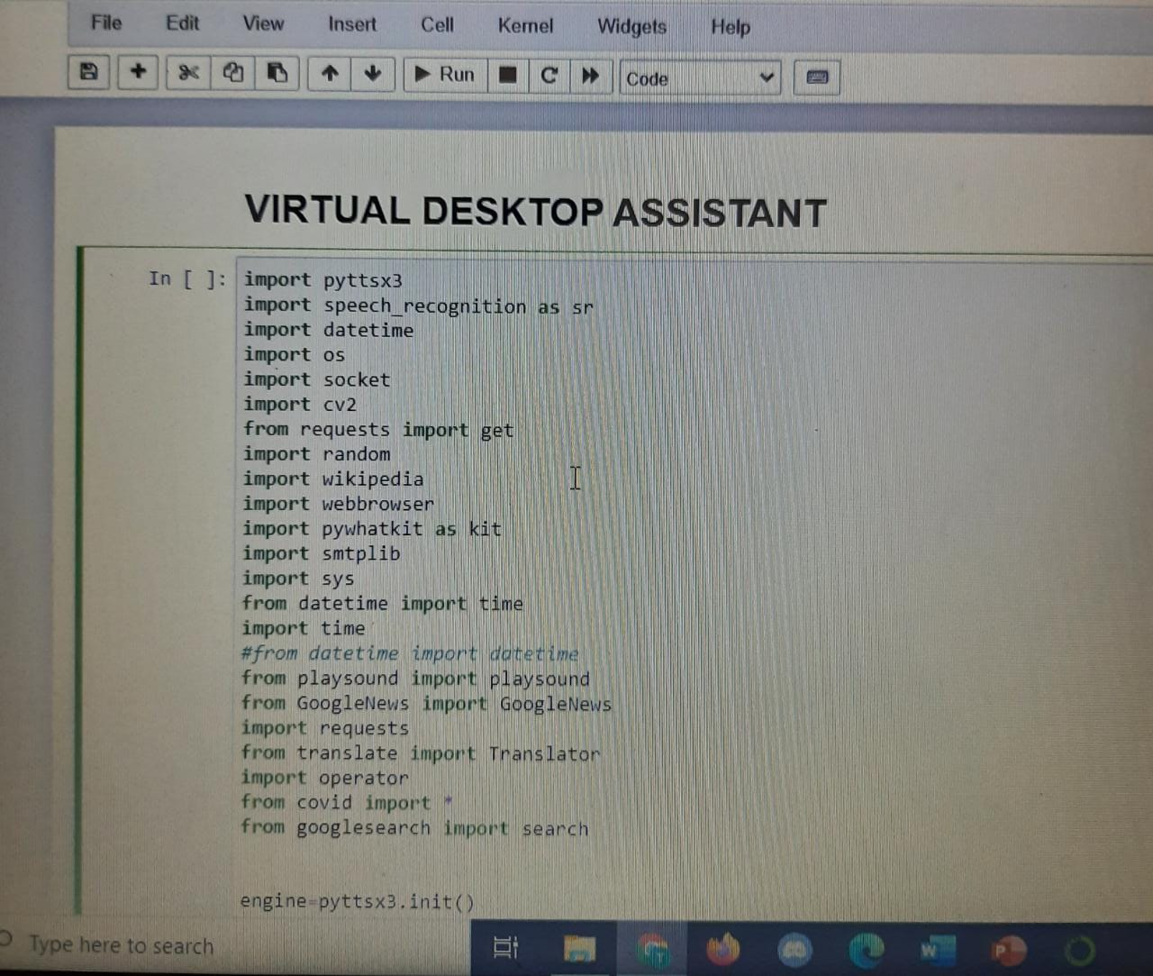

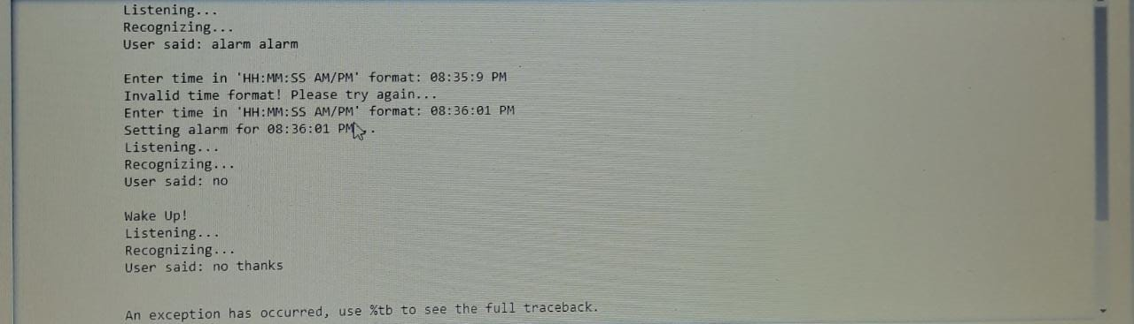

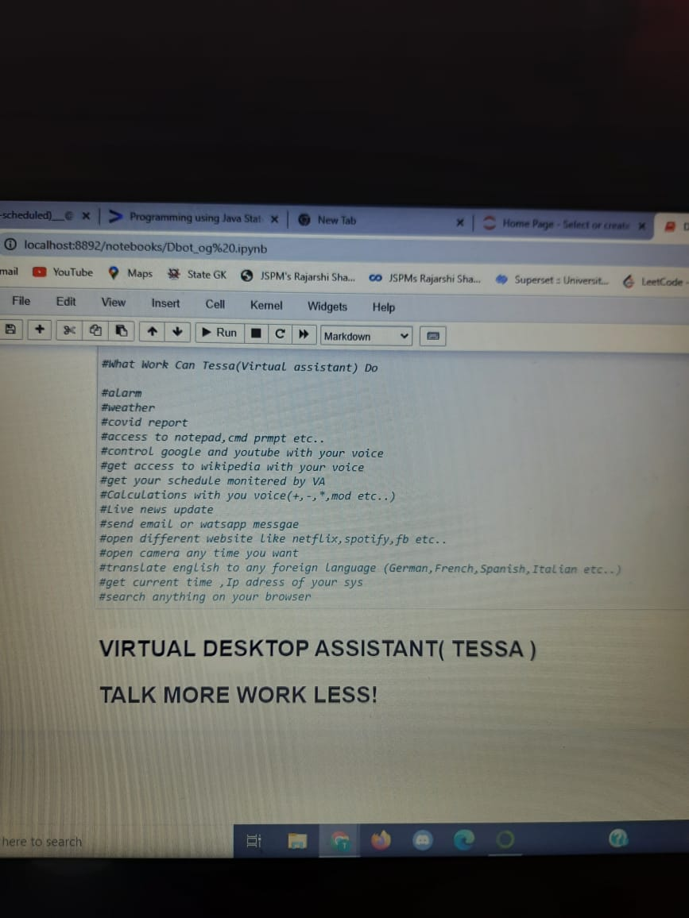

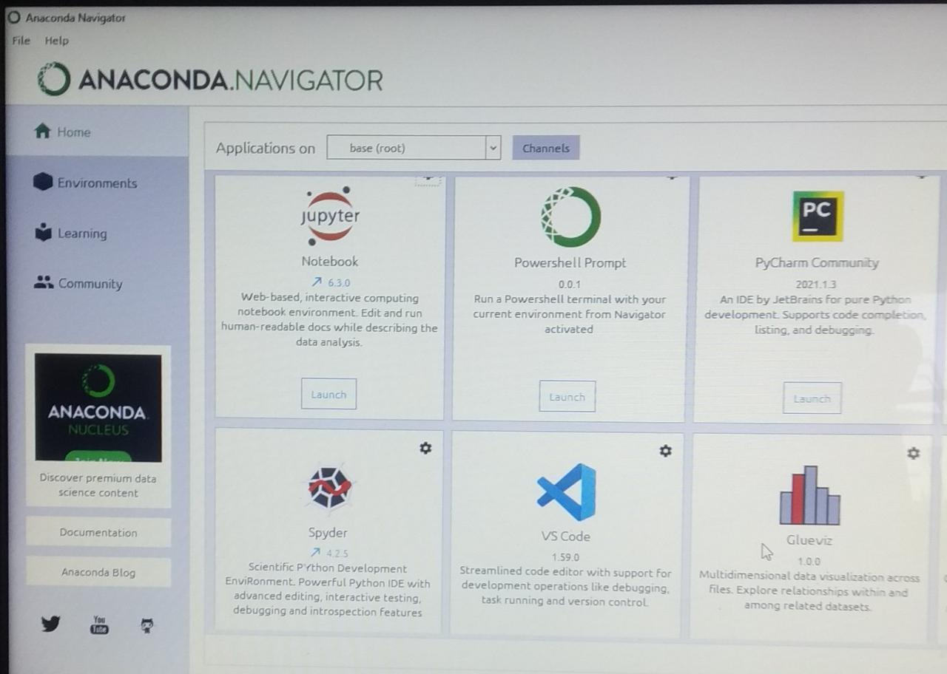

Sequence diagram for Query-Response

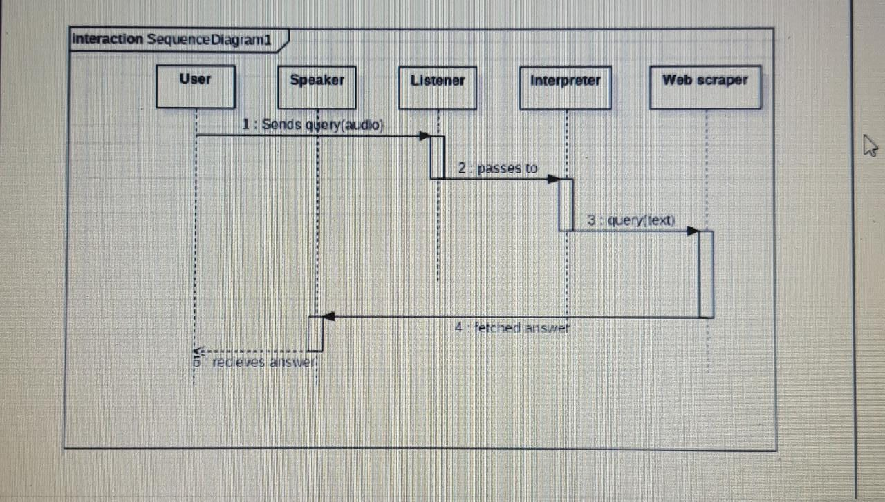

The above sequence diagram shows how an answer asked by the user is being fetched from internet. The audio query is interpreted and sent to Web scraper. The web scraper searches and finds the answer. It is then sent back to speaker, where it speaks the answer to user.

DATA FLOW DIAGRAM

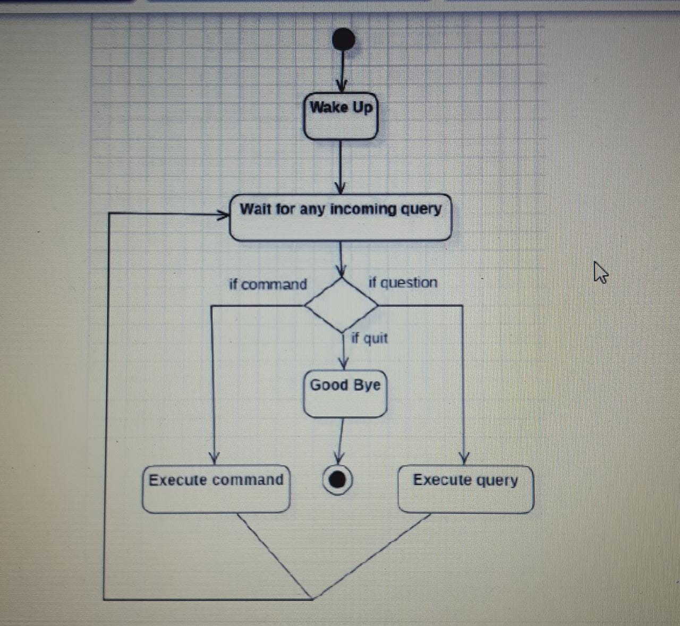

The main component here is the Virtual Assistant. It provides two specific service, executing Task or Answering your question.

**CONCLUSION:**

I] So now the virtual assistant will save time and money by doing the small tasks for you and doing them accurately and with high quality. If you handle the virtual assistant correctly, it will be a boom in your daily work.

II] It can take command by voice or type and perform the task you specify using speech recognition and perform task more fast than you can do.

*THANK YOU !*